**Data programming_Assignment_1**

**Question 1 C#**

What data type is each of the following?

|  |  |
| --- | --- |
| Questions | Data Type |
| 5 | Integer |
| 5.0 | float |
| 5 > 1 | Boolean |
| '5' | String |
| 5 * 2 | Integer |
| '5' * 2 | String |
| '5' + '2' | String |
| 5 / 2 | float |
| 5 % 2 | integer |
| {5, 2, 1} | List |
| 5 == 3 | Boolean |
| Pi (the number) | float |

**Question 2 C#**

Write (and evaluate) C# expressions that answer these questions:

a.How many letters are there in 'Supercalifragilisticexpialidocious'?

using System;

public class Count

{

public static void Main()

{

String string1 = "Supercalifragilisticexpialidocious";

int count = 0;

for (int i = 0; i < string1.Length; i++)

{

if (string1[i] != ' ')

count++;

}

Console.WriteLine("Total number of characters in a string: " + count);

}

}

b. Does 'Supercalifragilisticexpialidocious' contain 'ice' as a substring?

using System;

class substring

{

static void Main(string[] args)

{

String str = "Supercalifragilisticexpialidocious";

String value = "ice";

Boolean result = str.Contains(value);

Console.WriteLine($"Does string contain specified substring? {result}");

}

}

c. Which of the following words is the longest: Supercalifragilisticexpialidocious, Honorificabilitudinitatibus, or Bababadalgharaghtakamminarronnkonn?

using System;

public class longestword

{

public static void Main()

{

string[] words = { "Supercalifragilisticexpialidocious", "Honorificabilitudinitatibus", "Bababadalgharaghtakamminarronnkonn" };

int longestLength = words.Max(w => w.Length);

Console.WriteLine("The longest word is {0} characters long.", longestLength);

}

}

d. Which composer comes first in the dictionary: 'Berlioz', 'Borodin', 'Brian', 'Bartok', 'Bellini', 'Buxtehude', 'Bernstein'. Which one comes last?

class Program

{

    static void Main()

    {

        string[] a = new string[]

        {

            "Berlioz",

            "Borodin",

            "Brian",

            "Bartok",

            "Bellini",

            "Buxtehude",

            "Bernstein",

        };

        Array.Sort(a);

        foreach (string s in a)

        {

            Console.WriteLine(s);

        }

    }

}

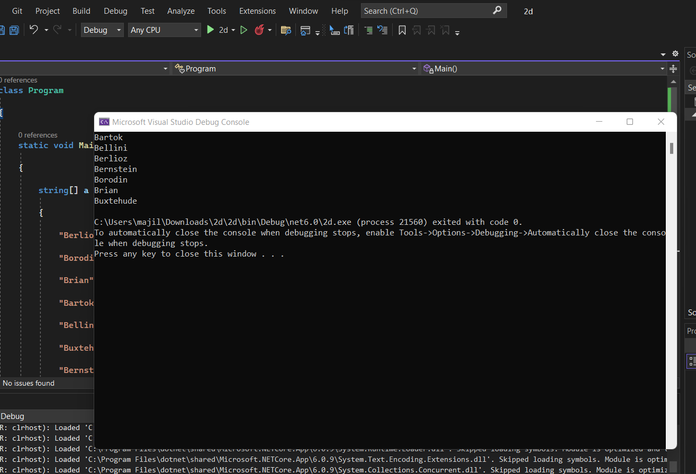

**Question 3 C#**

Implement function triangleArea(a,b,c) that takes as input the lengths of the 3 sides of a triangle and returns the area of the triangle. By Heron's formula, the area of a triangle with side lengths a, b, and c is s(s - a)(s -b)(s -c) , where s = (a+b+c)/2

using System;

public class AreaOfTriangle

{

public static void Main()

{

Console.Write("Enter the length of side 1:");

double side1 = Convert.ToDouble(Console.ReadLine());

Console.Write("Enter the length of side 2:");

double side2 = Convert.ToDouble(Console.ReadLine());

Console.Write("Enter the length of side 3:");

double side3 = Convert.ToDouble(Console.ReadLine());

double semiperimeter = (side1 + side2 + side3) / 2;

double Area = Math.Sqrt(semiperimeter * (semiperimeter - side1) * (semiperimeter - side2) * (semiperimeter - side3));

Console.Write("Area of a Triangle = " + Area);

Console.ReadKey();

}

}

**Question 4 C#**

Write a program in C# Sharp to separate odd and even integers in separate arrays.

using System;

public class oddoreven

public static void Main()

{

int[] arr1 = new int[10];

int[] arr2 = new int[10];

int[] arr3 = new int[10];

int i, j = 0, k = 0, n;

Console.Write("\n\nSeparate odd and even integers in separate arrays:\n");

Console.Write("------------------------------------------------------\n");

Console.Write("Input the number of elements to be stored in the array :");

n = Convert.ToInt32(Console.ReadLine());

Console.Write("Input {0} elements in the array :\n", n);

for (i = 0; i < n; i++)

{

Console.Write("element - {0} : ", i);

arr1[i] = Convert.ToInt32(Console.ReadLine());

}

for (i = 0; i < n; i++)

{

if (arr1[i] % 2 == 0)

{

arr2[j] = arr1[i];

j++;

}

else

{

arr3[k] = arr1[i];

k++;

}

}

Console.Write("\nThe Even elements are : \n");

for (i = 0; i < j; i++)

{

Console.Write("{0} ", arr2[i]);

}

Console.Write("\nThe Odd elements are :\n");

for (i = 0; i < k; i++)

{

Console.Write("{0} ", arr3[i]);

}

Console.Write("\n\n");

}

}

**Question 5 C#**

1. Write a function inside(x,y,x1,y1,x2,y2) that returns True or False depending on whether the point (x,y) lies in the rectangle with lower left corner (x1,y1) and upper right corner

(x2,y2).

using System;

class GFG

{

static bool FindPoint(int x1, int y1, int x2,

int y2, int x, int y)

{

if (x > x1 && x < x2 &&

y > y1 && y < y2)

return true;

return false;

}

public static void Main()

{

int x1 = 0, y1 = 0,

x2 = 2, y2 = 3;

int x = -1, y = -1;

if (FindPoint(x1, y1, x2, y2, x, y))

Console.Write("Yes");

else

Console.Write("No");

}

}

5.b)Use function inside() from part a. to write an expression that tests whether the point (1,1) lies in both of the following rectangles: one with lower left corner (0.3, 0.5) and upper right corner (1.1, 0.7) and the other with lower left corner (0.5, 0.2) and upper right corner (1.1, 2).

using System;

public class Rectangle

{

    public static void Main()

    {

        program(1, 2, 3.5, 4.6, 7.8, 5.8, 3.0, 7.9, 6.6, 2.3);

    }

    public static void program(int x, int y, double x1, double y1, double x2, double y2, double x3, double y3, double x4, double y4)

    {

        if (x > x1 && x < x2 && y > y1 && y < y2)

        {

            if (x > x3 && x < x4 && y > y3 && y < y4)

            {

                Console.WriteLine("True");

            }

        }

        else

            Console.WriteLine("False");

}

